

# Assignment JS Beginnings

Each question is 5 marks

Answer each question in your own words (No copy paste):

1. Variables are used to store data in, and have a name, type, and value assigned to them. They are called variables because they can have their value changed or *reassigned.*
2. The main differences between let and var is scope. Let operates on a localized block of code enclosed in {}, whereas a value defined by var can be accessed from anywhere. Reassigning a variable with var would thus reassign it everywhere. Const differs from both let and var in that the value of a variable declared with const cannot be changed.
3. window.alert (or simply alert) and console.log. Alert prints the output in a window and is designed more for the end user. Console.log outputs into the browser console and is for the programmer.
4. A template literal allows you to add expressions and variables into a string and is a way of getting around the use of quotation marks in a string.
5. Because the first 5 is a number, while the second 5 is a character
6. If statements contain a true/false question (the if part) and a condition, which can be thought of as “then”. They ask the program if the specified condition is true, and based on the answer, tell it what to do next. This can essentially be boiled down to “if this is true, do this, otherwise, do something else.
7. JavaScript is considered loosely typed because you don’t need to specify the variable type, as in whether it is a number or a character

8. Why wont the code in the image below reach line 5? 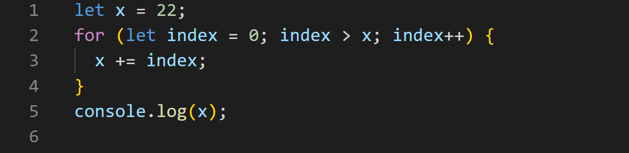

It won’t run because the index being > 22 is not true when the loop starts

1. ++ indicates that a value increments by one each time it passes through a loop, until a specified condition is met. It is a useful function because it eliminates the need for repeating lines of code to achieve the same thing

10.

let a = 12

let b = 3

let sum = a + b

let difference = a - b

let product = a * b

let quotient = a / b

console.log(`"${a} + ${b} = ${sum}", "${a} - ${b} = ${difference}", "${a} * ${b} = ${product}", "${a} / ${b} = ${quotient}"`)

11.

let name1 = prompt("What is your first name?", "Jeff")

let name2 = prompt("What is your last name?", "Bezos")

let age = prompt("How old are you?", "58")

let job = prompt("What is your occupation?", "business owner")

alert(`"Hi, my name is ${name1} ${name2}. I am ${age} years old and I am a ${job}`)

12.

let a = +prompt("Input a number");

let b = +prompt("Input a number");

if (a % 2 !== 0 && b % 2 !== 0) {

  alert(a * b);

} else if (a % 2 == 0 && b % 2 == 0) {

  alert(a / b);

} else if (a % 2 !== 0 && b % 2 == 0) {

  alert(a + b);

} else if (a % 2 == 0 && b % 2 !== 0) {

  alert(a - b);

}

13.

let userNumber = 3;

let counter = 1

for (let counter = 1; counter <= 100; counter++) {

  console.log(`${counter} * ${userNumber} = ${counter * userNumber}`);

}

True and False (Feel free to explain if you are uncertain):

14. False

15. False

16. False

17. True

What is the output:

18. c

19. Nice "a"!

20. It is true that your number is Prime

**End!**